

**MALAD KANDIVALI EDUCATION SOCIETY’S**

NAGINDAS KHANDWALA COLLEGE OF COMMERCE,

ARTS & MANAGEMENT STUDIES & SHANTABEN NAGINDAS KHANDWALA COLLEGE OF SCIENCE

MALAD [W], MUMBAI – 64

(AUTONOMOUS)

(Reaccredited ‘A’ Grade by NAAC)

(AFFILIATED TO UNIVERSITY OF MUMBAI)

(ISO 9001:2015)

## CERTIFICATE

**Name: Mr. SATYAM VIGNESH JHA**

**Roll No: 30 Programme**: BSc IT/CS **Semester**: II

This is certified to be a bonafide record of practical works done by the above student in the college laboratory for the course **IT platforms, Tools and Practices** (Course Code: **2026UISTP**) for the partial fulfillment of Second Semester of BSc IT/CS during the academic year 2020-2021.

The journal work is the original study work that has been duly approved in the year 2020-2021 by the undersigned.

**External Examiner** **Subject-In-Charge**

**(Ms.Sweety Garg)**

**Date of Examination: (College Stamp)**

NAME: SATYAM VIGNESH JHA ROLL NO : 30

|  |  |  |  |  |
| --- | --- | --- | --- | --- |
| **Sr. No.** | | **DATE** | **TITLE** | **SIGN** |
| 1. | 2/2/21 | INTRODUCTION and CONTRIBUTING TO WIKIPEDIA  a) What is Wikipedia?  b) Steps to Create Account on Wikipedia  c) Creating Page on Wikipedia  d) Edit your page |  |
| 2. | | 9/2/21 | [Creating account, repository on GitHub and Cloning repository in GitHub Page](http://elearning.nkc.org.in:81/moodle/mod/page/view.php?id=2178) |  |
| 3. | | 16/2/21 | BASIC UNDERSTANDING ON FREE AND OPEN-SOURCE SOFTWARE   1. Describe Open-Source Software with Example. 2. Describe Free Software with Example 3. Difference between Free and Open-Source Software. |  |
| 4. | | 23/2/21 | WRITING EMAIL |  |
| 5. | | 25/2/21 | Using practical examples, describe green computing. List and explain the steps that you take to contribute to green computing |  |
| 6. | | 2/3/21 | WRITING BLOGS |  |
| 7. | | 9/3/21 | Implementing coding practices in Python using PEP8. |  |
| 8. | | 18/3/21 | PRESENTATION: GREEN COMPUTING AND ITS APPLICATIONS____________________________ |  |

**PRACTICAL 1**

**PRACTICAL1: INTRODUCTION AND CONTRIBUTION TO WIKIPEDIA**

1. Description about Wikipedia and its Features

**Wikipedia is a free**, multilingual open-collaborative online

encyclopedia **created and maintained by** a community of volunteer

editors **using** a wiki**-based editing system. It is one of the 15 most popular**

**websites as ranked by** Alexa, as of January 2021. The

Economist **newspaper placed it as the "13th-most-visited place on the**

**web"**. **Featuring no** advertisements, **it is hosted by the** Wikimedia

Foundation, **an** American non-profit organization **funded primarily through**

**donations.**

**Wikipedia was launched on January 15, 2001, by** Jimmy Wales **and** Larry

Sanger. **Sanger coined its name as** a portmanteau **of** "wiki" **and**

"encyclopedia". **It was initially an** English-language encyclopedia, **but**

**versions in** other languages **were quickly developed. With** 6.2 million

articles**, the English Wikipedia is the largest of the 317 Wikipedia**

**encyclopedias. Overall, Wikipedia comprises more than 55 million articles,**

**attracting 1.7 billion unique visitors per month.**

FEATURES:

**1) Create a page**

To contribute to a Wiki, you'll start by creating a page. All pages have a title and text. Unlike

pages of a normal website, you won't need to know any code to contribute content here. You

can write and format text on a Wiki page like you would an email.

**Edit a page**

Published pages can be edited by anyone that reads them. If, for example, you notice that a

page created by someone else contains inaccurate/outdated information, you can open the

editing screen and correct that information directly.

**Link between pages**

Linking between Wiki pages makes it easier for readers to find secondary materials

they may need, especially as your Wiki grows

1. Creating Account on Wikipedia

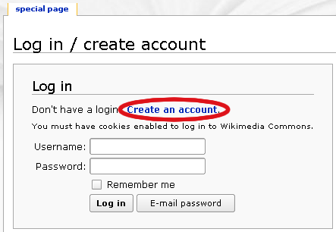

1. Click on: Create Account

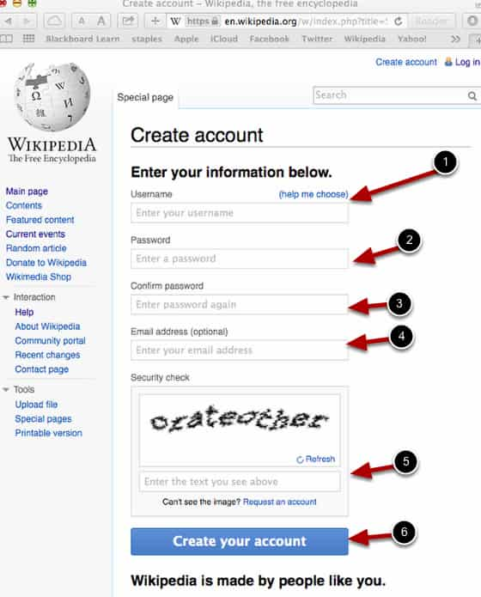

1. Enter the details and Click on: Create your account

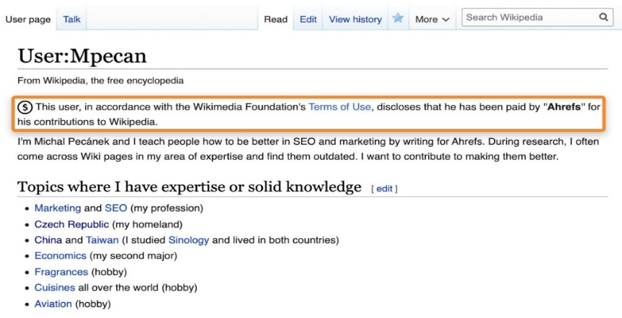

3) Your page will create.

c) Creating your page on Wikipedia

1. After creating account click on log in

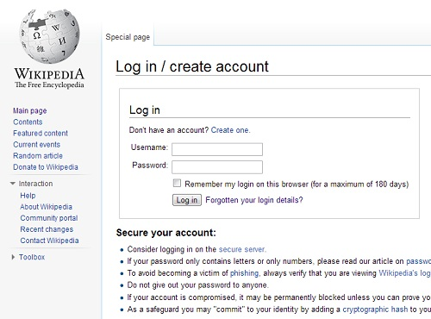

1. Enter your Username and password

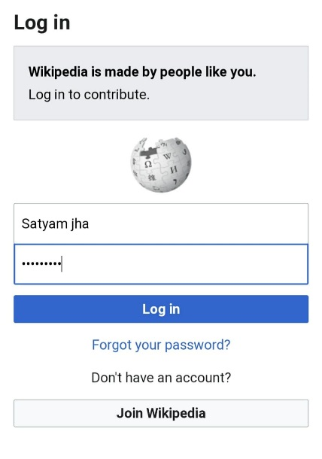

# 

# 3) Your account will open and search your name in search Wikipedia

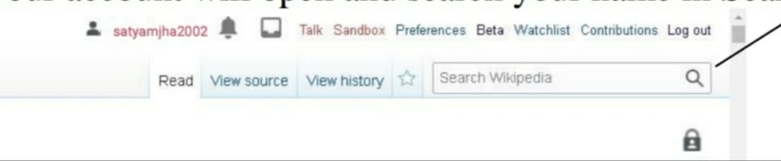

4) Then click on “ask for it to be created

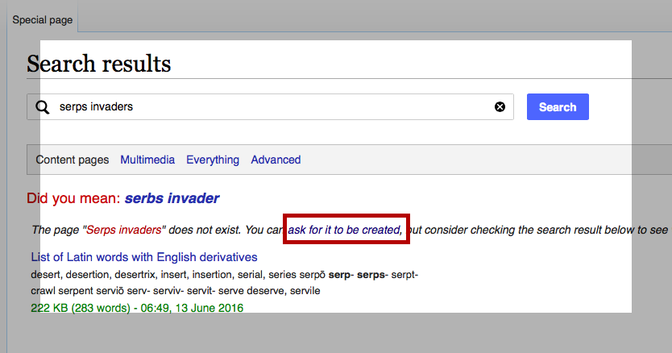

5) Then click on “Click here to start a new article

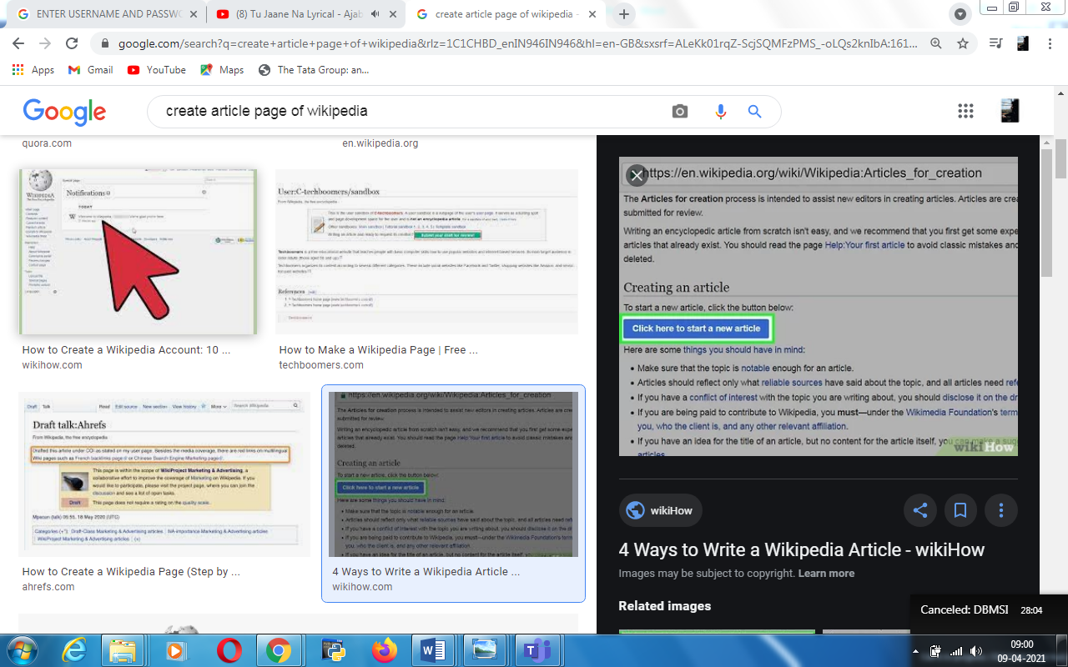

6) Then simply click on Next-Next –I’ m writing about …… subject

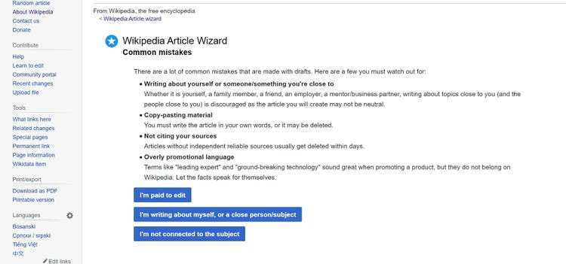

Then click on “I have Disclosed”

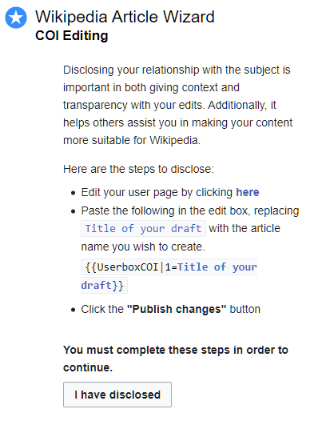

Write a draft name

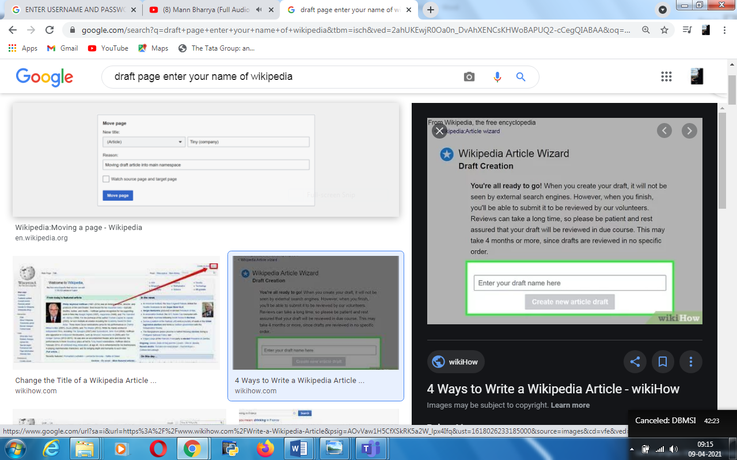

Click on “Starting editing”

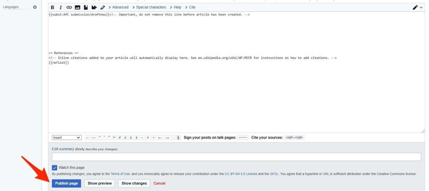

Start creating your page

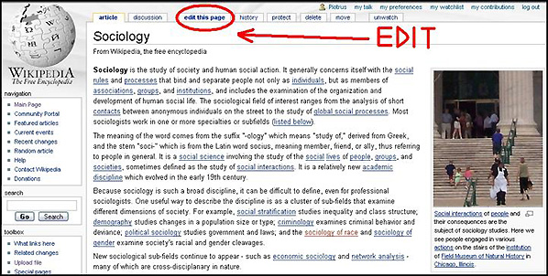

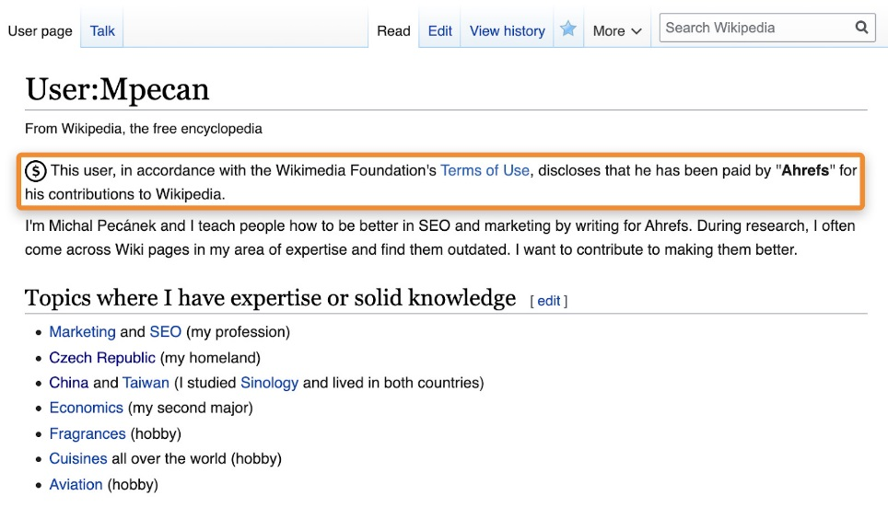

At last click on “Publish page”

YOUR PAGE WILL CREATED

c) Editing your page on Wikipedia

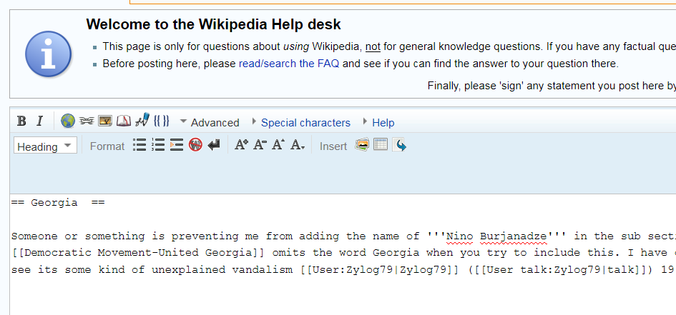

**PRACTICAL 2**

**PRACTICAL 2: CREATING ACCOUNT , REPOSITORY ON GITHUB AND CLONING REPOSITORY IN GITHUB**

**a) Creating Account**

**1) Open the GitHub website**

**2) Click on Sign up**



**3) Create your account by filling form and click on Create account**

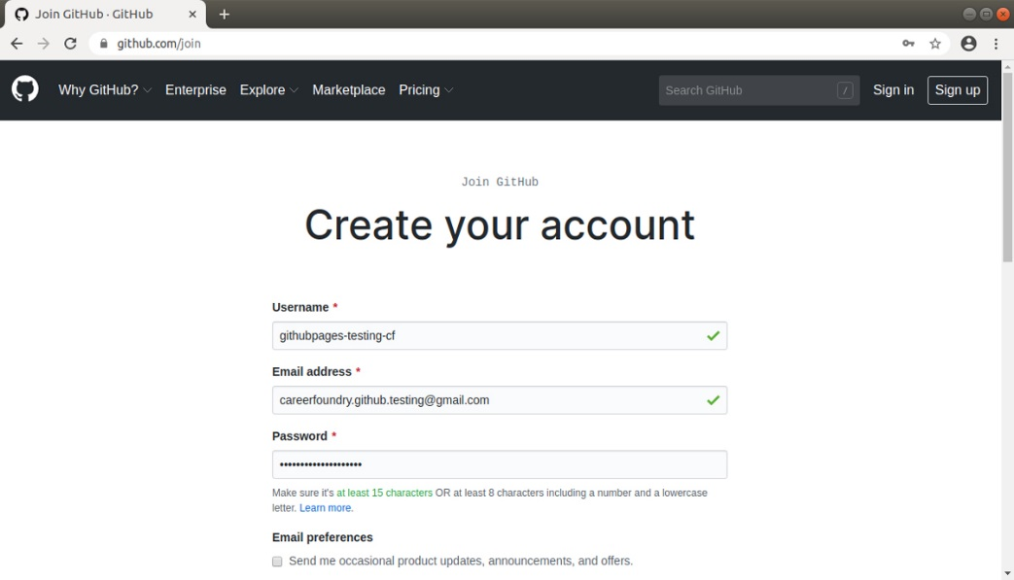

**4) Your account will create and you get a welcome page**

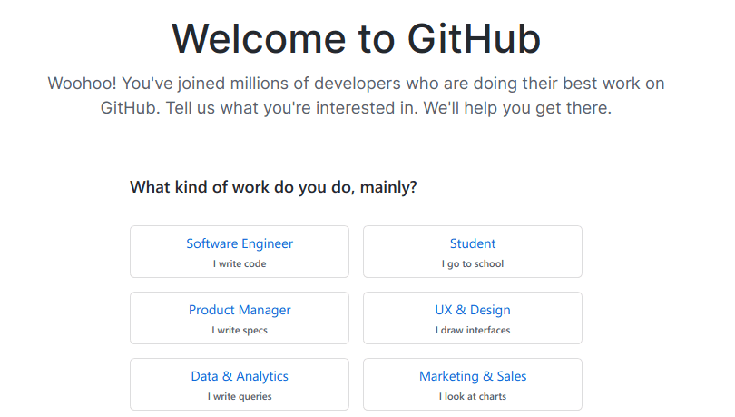

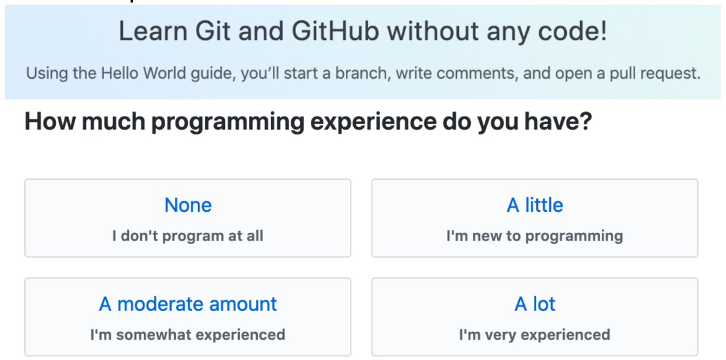

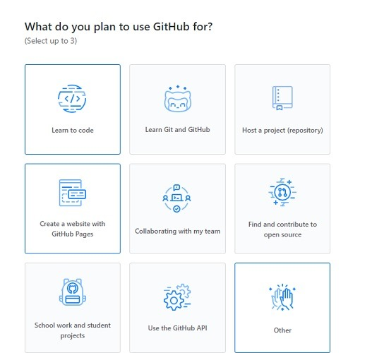

**5) Choose the options according to your comfort and click on complete setup**

**6) Then you have to verify your email address by going on mail**

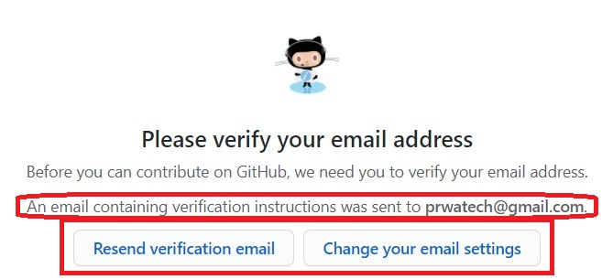

**7) As soon asoyu verify your E-mail, a page will open showing that “**Your email was verified’’**.**

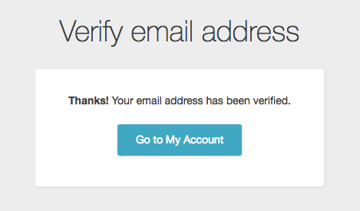

**b) Creating Repository**

**1) Once you got the verification page, you can click on create repository**

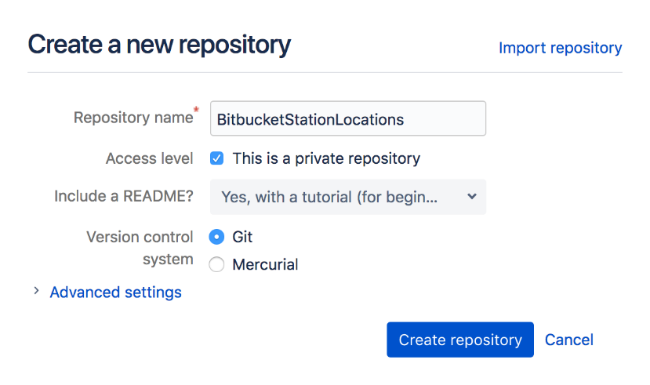

**2) your new repository will create**

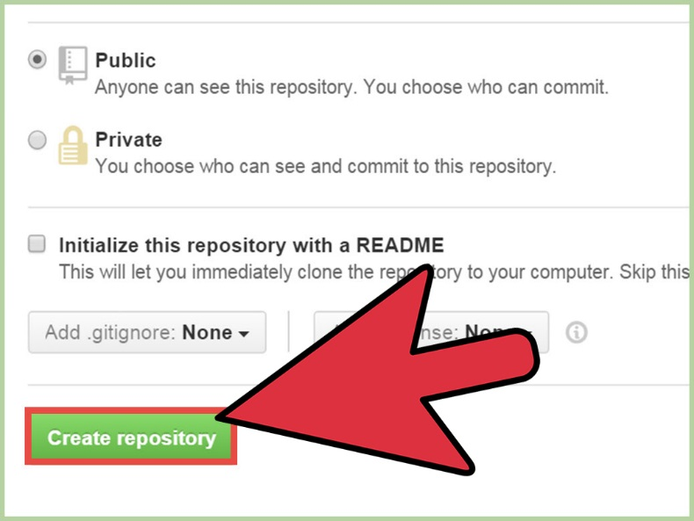

**c) Cloning repository**

**Cloning means to get a code of your fileand send someone so he/she can access your file.**

**1) First go to your account and go to code.**

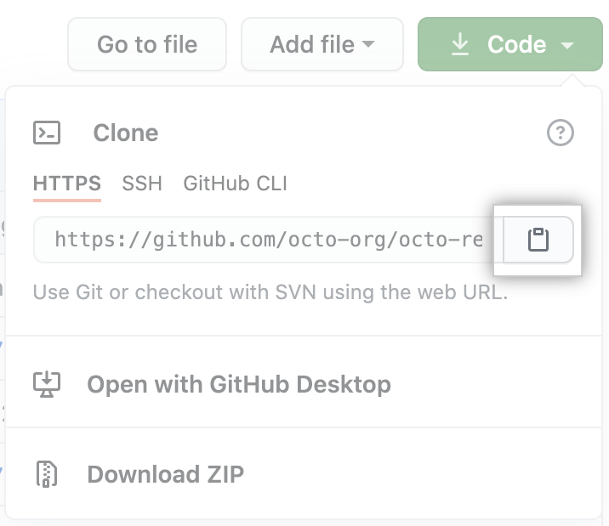

**2) Click on Add file. Either you Create new file or Upload file.**

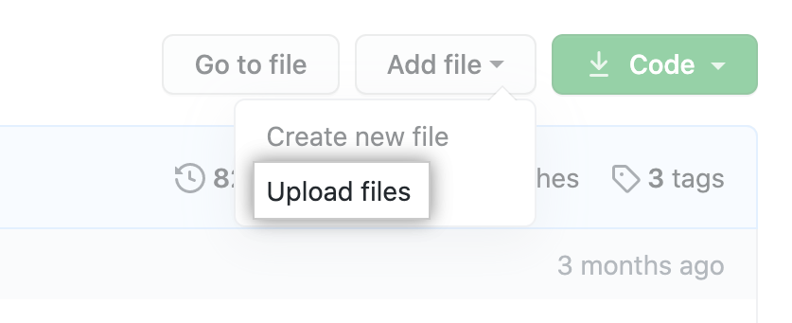

**3) Give name to file and select Readme option.**

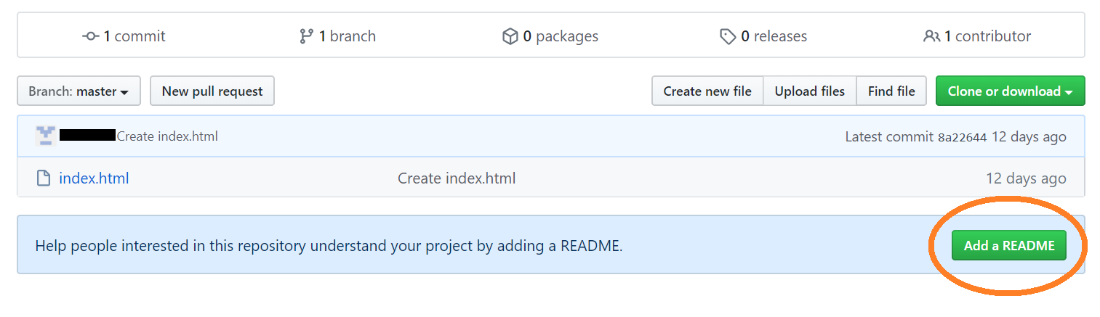

**4) As you click on commit, your file will created.**



**5) Click on clipboard icon under Clone option, right of the file box. From there you can copy link of the file and this known as Cloning Repository.**

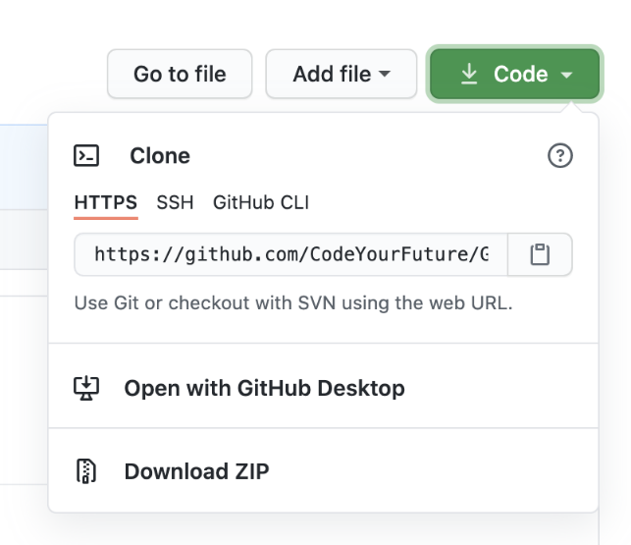

**PRACTICAL 3**

**PRACTICAL 3: BASIC UNDERSTANDING ON FREE AND OPEN-SOURCE SOFTWARE.**

a) Describe Open Source Software with Example.

**Open-source software** (**OSS**) is a type of [computer software](https://en.wikipedia.org/wiki/Software) in which [source code](https://en.wikipedia.org/wiki/Source_code) is

released under a [license](https://en.wikipedia.org/wiki/Open-source_license) in which the [copyright](https://en.wikipedia.org/wiki/Copyright) holder grants users the rights to use,

study, change, and [distribute the software](https://en.wikipedia.org/wiki/Software_distribution) to anyone and for any purpose.[[1]](https://en.wikipedia.org/wiki/Open-source_software#cite_note-1) Open-

source [software](https://en.wikipedia.org/wiki/Software) may be developed in a [collaborative public manner](https://en.wikipedia.org/wiki/Open-source_model).

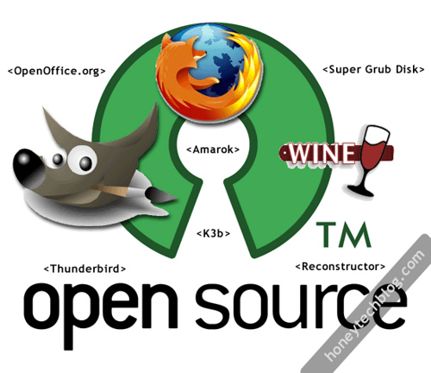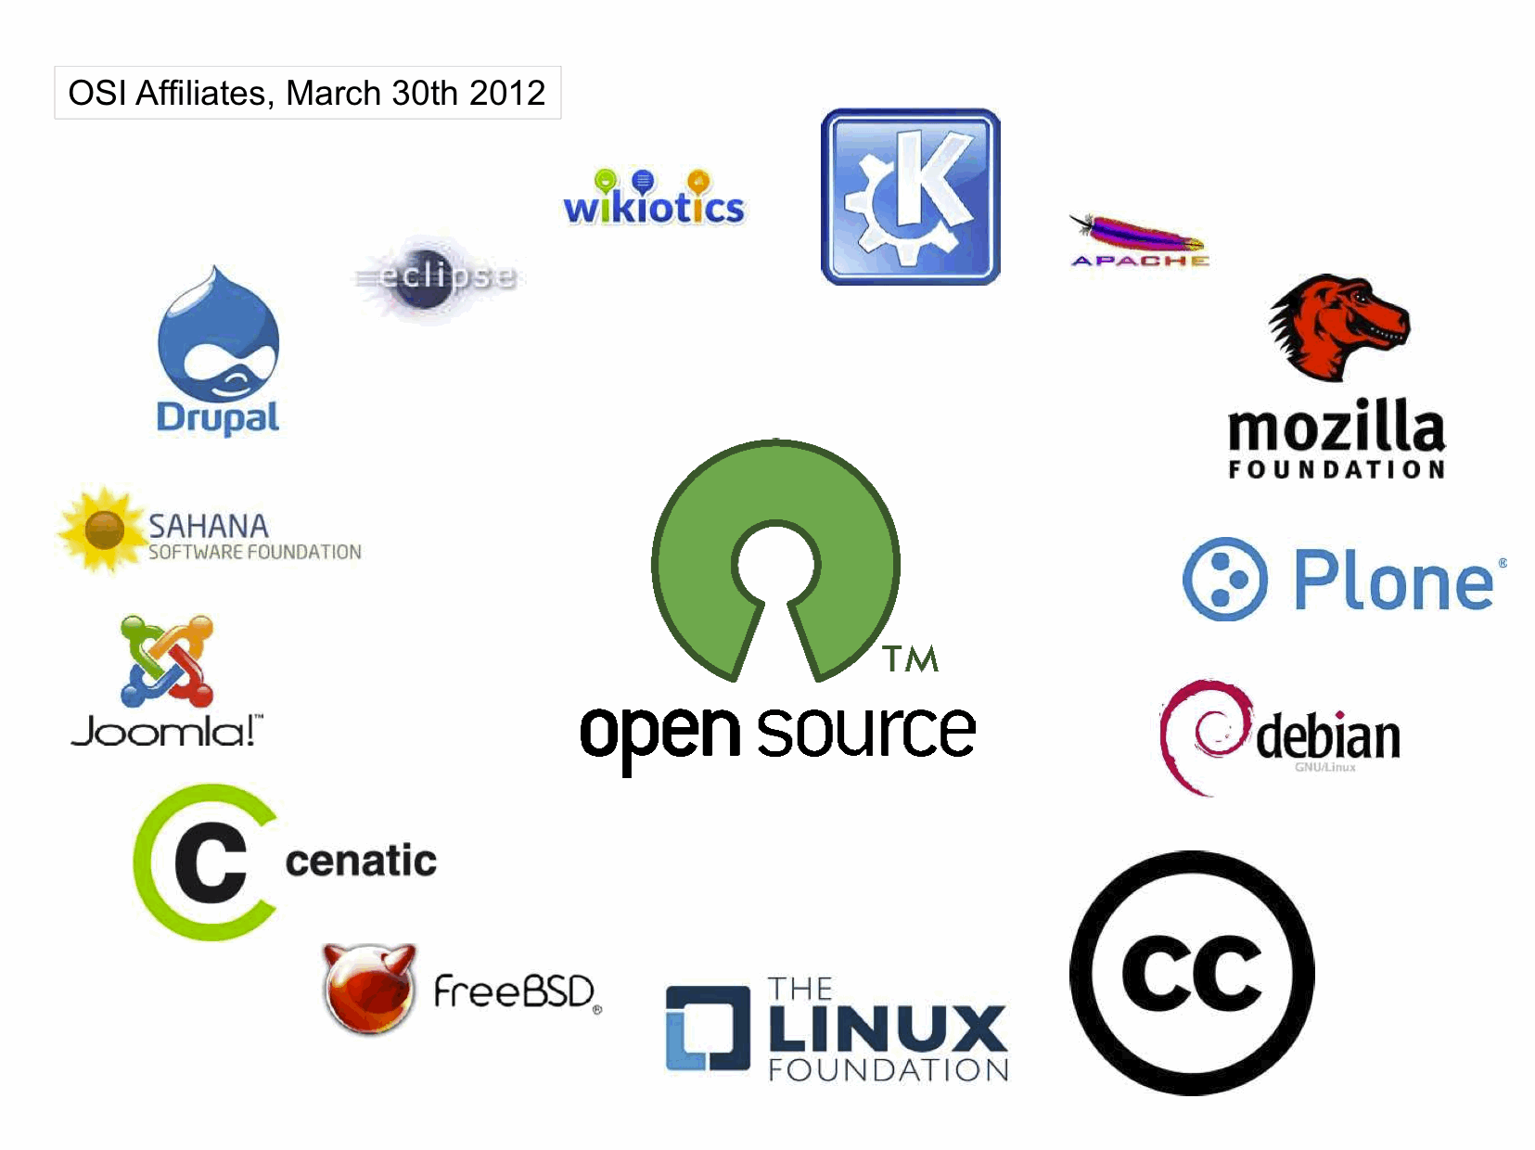

Open-source technologies helped establish much of the internet. Furthermore, many of

the programs in use every day are based on open-source technologies. Cases in point:

Android OS and Apple’s OS X are based on the kernel and Unix/BSD open-source

technologies, respectively.

Other popular open-source software is:

* Mozilla's Firefox web browser
* Thunderbird email client
* [PHP](https://www.thebalancecareers.com/websites-for-learning-php-2071891) scripting language
* Python [programming language](https://www.thebalancecareers.com/high-paying-programming-languages-2071890)
* Apache HTTP web server

b) Describe Free Software with Example

Free software is a term coined and promoted by the GNU project and Free Software Foundation. It is used for open source software which allows users to freely look at the source of the software, modify it, distribute it, and use it without any restriction. Software available without any payment is not necessarily free software. According to the definition as presented by the Free Software Foundation, the word Free in “free software” implies the idea of freedom rather than not having a cost. If software is available to be downloaded without being paid for, but the user is not able to modify the source then it is not free software. It is important to note the distinction

here. Freeware is software that you don’t have to pay for. Free software is software you are free to modify and use for your own purposes. Freeware does not necessarily have to be free software as the source code can still be protected.

**Examples of free software applications**

* The Linux kernel, of course! The Linux kernel is protected by the GPL, and is

used daily by millions of people throughout the world. ...

* Apache, the most widely used web server in the world. ...
* The Gimp is a powerful bitmap mode digital creation program. ...
* PostgreSQL is an object-relational database.

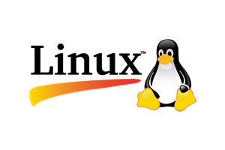

c) Difference between Free and Open Source Software.

**Free Software:**

“Free software” means software that respects users’ freedom and community. Roughly, it

means that the users have the freedom to run, copy, distribute, study, change and improve

the software.The term “free software” is sometimes misunderstood—it has nothing

to do with price. It is about freedom.

1. Free Software is an important part of people’s lives.

2. Free Software freedom translates to social freedom.

3. Freedom is a value that is more important than any economical

advantage.

4. Examples: The Free Software Directory maintains a large

database of free-software packages. Some of the best-known

examples include the Linux kernel, the BSD and Linux operating

systems, the GNU Compiler Collection and C library; the MySQL

relational database; the Apache web server; and the Sendmail

mail transport agent.

Open Source Software :

Open Source Software is something which you can modify as per your

needs, share with others without any licensing violation burden. When

we say Open Source, source code of software is available publicly with

Open Source licenses like GNU (GPL) which allows you to edit source

code and distribute it. Read these licenses and you will realize that

these licenses are created to help us.

1. Coined by the development environments around software produced

by open collaboration of software developers on the internet.

2. Later specified by the Open Source Initiative (OSI).

3. It does not explicitly state ethical values, besides those directly

associated to software development.

4. OpenSource Software is just software. There are no ethics

associated directly to it.

5. Freedom is not an absolute concept. Freedom should be allowed,

not imposed.

6. Examples: Prime examples of open-source products are the Apache

HTTP Server, the e-commerce platform osCommerce, internet

browsers Mozilla Firefox and Chromium (the project where the vast

majority of development of the freeware Google Chrome is done)

and the full office suite LibreOffice.

**PRACTICAL 4**

**WRITING AN EMAIL**

**Here is some tips Which you can use to make your email more effective:**

**Rule #1: Imagine Receiving The Email You’ re Writing**

Imagine that you are going to receive this Email. If you want to receive a ggod Email, Write good Email.

**Rule #2: Write Like You Talk**

**1. The Subject Line**

Write the Subject

Here are some example:

* I’m going to be in Town next Tues- are you available?

* Introduction to be Kevin Bacon

**2. Start with an appropriate greeting.**

* Dear [First Name]

* Dear Mr./Ms [Last Name]

* [Name]

* Good morning/afternoon

* Hi

* Hey

* Hey/Hi there

**3**. **Keep your message short and concise.**

If your message is short so one can read your Email without any stress but as he/she saw that the Email is very large may be he/she feel bored for reading your Email.

**4. Use standard fonts.**

* Arial

* Courier

* Helvetica

* Lucida Sans

* Tahoma

**5. Writing your Closing.**

You should write closing part It not only looks good but also affect the person also.

* Yours sincerely

* Yours truly

* Yours

* Sincerely

* Best regards

* Best

**6. Schedule your emails.**

Send Emails at a specific time. You should know when will you get the respond immediately.

7. **Do a final spelling and grammar check.**

After writing Email,cross check yourv Emailonce.

**Here is an example of Email:**

This is the window where you write your email. To open this simply go to Gmail. Click on Compose on the left side.

Give the Recipient email and give a suitable subject related to yourcontent. Start writing you Email. You can do formatting with options given n the bottom part.

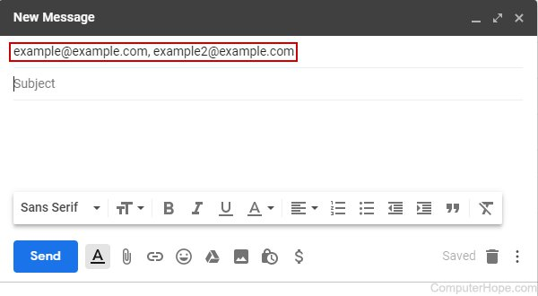

**This is an example of Leave Application.**

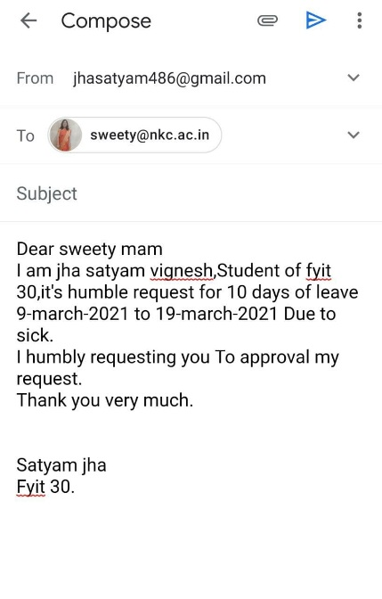

**PRACTICAL 5**

Using practical examples, describe green computing. List and explain the steps that you

take to contribute to green computing.

**DESCRIBING GREEN COMPUTING:**

Green computing is the environmentally responsible and eco-friendly use of computers

and their resources. In broader terms, it is also defined as the study of designing,

manufacturing/engineering, using and disposing of computing devices in a way that

reduces their environmental impact.

**The strategies of Green** **computing** have decreased the consumptionof overhead energy

and have used the server maximum through astrategy including server virtualization. But

technology trends, suchas increase in data analytics and artificial intelligence, can reduce

pro-in green computing strategies.

**Examples of Green Computing**

• Renewable Energy Sources

• Renewable energy sources don’t use fossil fuel.

They are available freely, are environmentally friendly and generate

less pollution. Apple, who is building a new corporate center, is plan-

ning to use most of the building’s wind turbine technology, and

Google has already built a wind-powered data center.

At the most simple level, green computing is not a rocket science and

certainly does not require large amounts of cash in case of up-front

investment. As stated above, the active step for a green computing

takes a little effort, yet low energy consumption usually changes to

immediate savings.

**Steps that we can take to contribute to green computing:**

1) Power down when not in use seems simple but many of us powered up for a long time

when not in use a large sum ofpower is being wasted, so if you're notusing the computer

press the power button to shut it off until needed. This can be done even if thecomputer is

working on something. Screensavers do not save power.Same goes for computers, you

don't have to shut it down completelyif you don't want to reboot, just use sleep or

hibernation mode. Thiswill help save energy and keep the system to its current state

whenyou need it again.

2) Use the power saving features. All computers include power savingoptions.

Usingthese features you can command the computer to dovarious energy-saving

tasksautomatically, including shutting off un-used hard disks, powering off a monitor

after a given time or even placing the computer into sleep mode when not in use. This is

very useful on laptops to help preserve battery life.

3) Purchase energy saving hardware If you don't need super-fast com-puting power then

look out for energy efficient components when buying a new computer, such as green

hard drives and low-energy processors. While performance is slower they can use

remarkably less power. Purchasing an energy saving power supply unit for a desktop

PC can help the environment and save money, they're often quieter too.

4) Use a laptop instead of desktop Laptops are much better for the environment than

desktop computers as they have components which require less power. If you don't need

a desktop computer consider buying a laptop instead, or if you have both use the laptop

as much as possible before considering the desktop.

5) Recycle responsibly Computer hardware is filled with different material which can be

hazardous to the environment so make sure you dispose of old components effectively.

Don't just throw broken technology in the bin, take the time to trace local recycling

organizations. There should be companies which can remove the metals which may fix or

furnish items. You should check with your local authorities to find out what facilities

they offer for safe disposal of old computing parts.

**PRACTICAL 6**

**WRITING BLOGS**

**1. Open blogger.com website.**

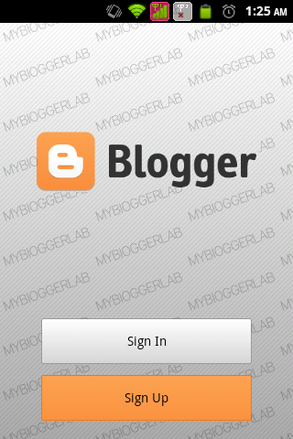

**2. Choose an account for doing further process.**

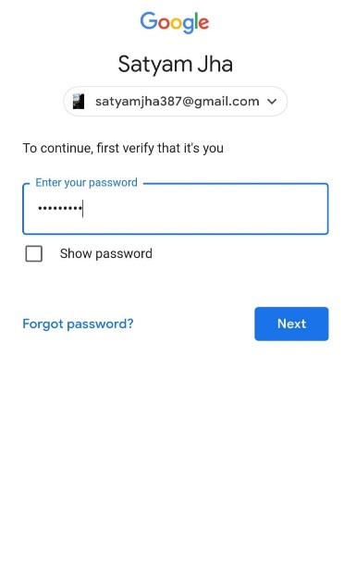

**3**. **After Choosing account, set a password**

**4. Write a name for your blog.**

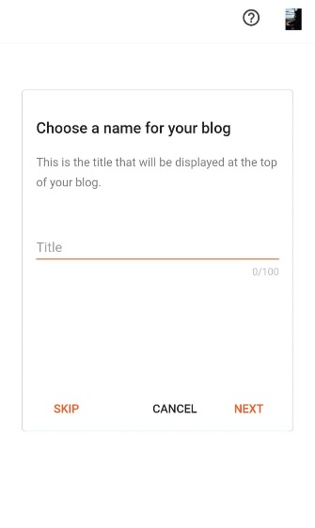

**5. Write a url from which anyone can see your blog through that link**

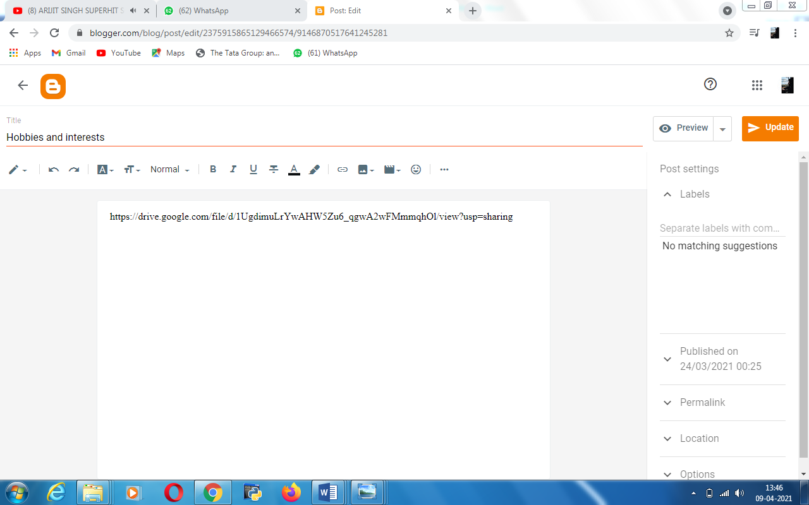

**6. This page will open when all process will complete. From here you can start creating your wonderful blog.**

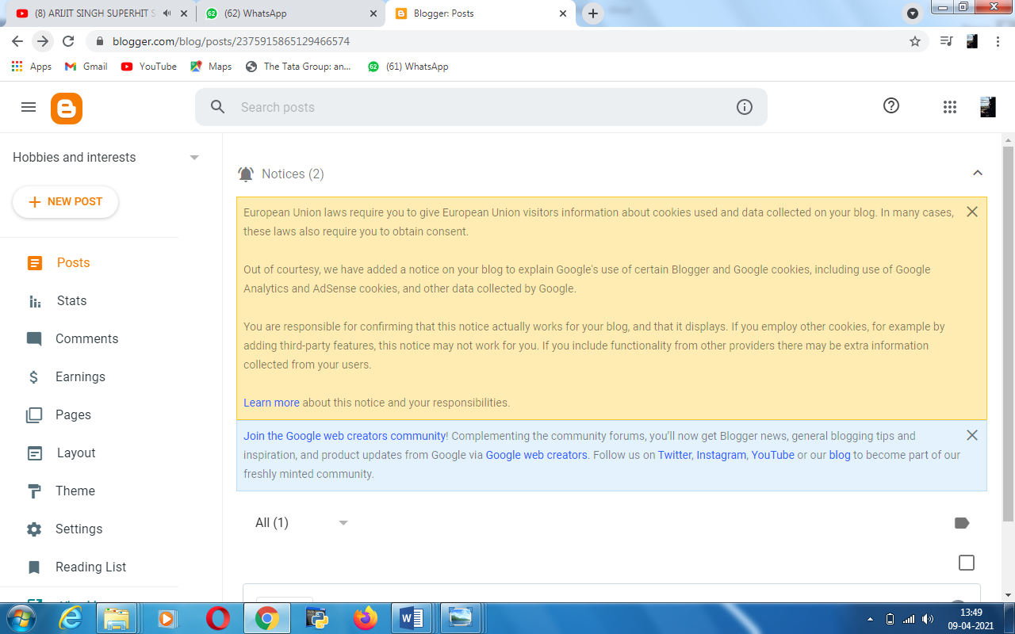

**8. You can also see preview that how your blog looks like.**



**9. Example of blog.**

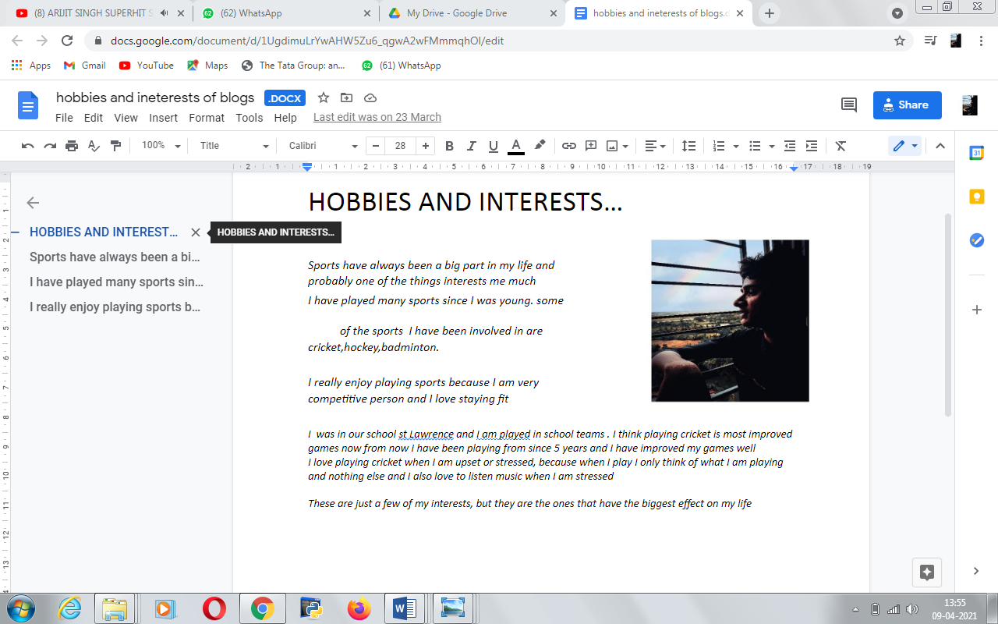



**PRACTICAL 7**

**Implementing coding practices in Python using PEP8**.

As Guido van Rossum said, “Code is read much more often than it is written.” You may

spend a few minutes, or a whole day, writing a piece of code to process user

authentication. Once you’ve written it, you’re never going to write it again. But you’ll

definitely have to read it again. That piece of code might remain part of a project you’re

working on. Every time you go back to that file, you’ll have to remember what that

code does and why you wrote it, so readability matters. PEP stands for Python

Enhancement Proposal, and there are several of them. A PEP is a document that describes new features proposed for Python and documents aspects of Python, like

design and style, for the community.Writing clear, readable code shows professionalism.

It’ll tell an employer that you understand how to structure your code well. If you have

more experience writing Python code, then you may need to collaborate with others.

Writing readable code here is crucial. Other people, who may have never met you or seen

your coding style before, follow and recognize will make it easier for others to read your

code.

**Coding using PEP 8:**

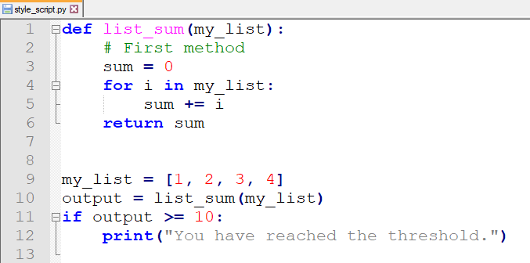

Another Example:

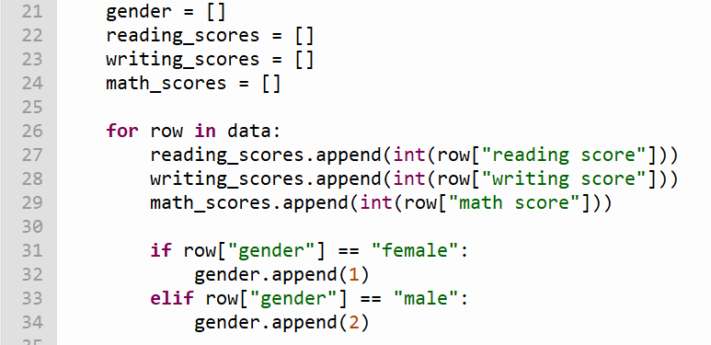

**PRACTICAL 8**

**PRESENTATION**





